Contents
Document Version Control 1
Approved process for raising 1
Consultation & Approval 1
Change Management 1
How to 1
Testing 2
Communications 2
Downstream Systems & Processes 2
Affected Reports 2
Additional Background Information 2

Document Version Control
Change History/Review Details
Date | Version | Review by | Summary of Change
28/Apr/17 | 0.1 | HC | initial draft
4 Jan 2019 | 0.1 | HC | Further detail added

Approved process
Does the change need to be raised through a particular route or by a particular person/team? Are there any actions which need to be taken or considered prior to processing in the HRIS Support Centre?
A request to change an application form(s) could come from any source and may often be the result of legislative changes or a business Requirement. For example changes to reflect new or updated legislation around GDPR or Equality and Diversity are likely to come from the teams responsible for these areas.

Any changes to the online application form profile(s) must follow the Change Management process in force at the time of the change.

Changes may need to be presented at HRSEG for agreement before being implemented.

Consultation & Approval
Who is the owner of this information? Who needs to be consulted about this change before you begin work on it? Does anyone need to approve this change before it is implemented?
The University’s central recruitment team within Personnel Services may need to be consulted about any changes to the application forms if they have not requested them. They are responsible for the overall recruitment strategy and policies.

Change Management
What type of change is this? When should approval be sought and from whom (internal to team or change manager)? Who would normally be responsible for implementing?
The system changes must be approved by the System Owner (the Head of HRIS Support) or their nominated deputy, via the change request in HEAT, ideally before implementation.

How to
Technically how to process the change in the system
Adding a new ….
Full details can be found in the guide HOW TO Maintain Online application Forms

The Online forms are created and maintained in the Portal.

Navigate to: Portal > Recruitment Dashboard > Toolbox > Recruitment Admin… Form Profile > Edit Profile

The standard Additional Questions section is partially maintained in the back office and partially in the portal.

Navigate to: Personnel > Recruitment > Recruitment Reference > Question Category OR
Portal > Recruitment Dashboard > Toolbox > Recruitment Admin … Form Profile > Edit Profile > Questionnaire Section

The Non-standard additional questions e.g. Clinical Appointments, are also maintained in the back office.

Navigate to: Personnel > Reference > User Defined Field Codes … Question Profile

Adding a ….
Navigate to: As Above

New Sections can be added by choosing the New Section option.

Other options:
Option | Purpose
sign next to section heading | Expand section to view current items included within it
 | add/remove items or change the settings for existing items in a section
 | edit a section heading or add/remove/change section help/instruction text for applicants
 | Change the order (sequence) of items in that section

Changing a ….
Navigate to: As Above

Removing a ….
Navigate to: As Above

Standard Icons & Terminology
Standard Button Names  Enter Query button:  Previous Record button:  Previous Section button:  Save button:  Insert Record button: | Execute Query button:  Next Record button:  Next Section button:  LOV button:  Delete Record button: | Cancel Query button:  Red Door button:  Duplicate Record button:
Navigation Paths

Show the final navigation path option in bold+italics, for example;

Core|Personnel > Reference > Reference A – C > Accident Codes
Core|Pay > Reference > Pay Groups

Any further navigation beyond the navigation path can be added after an ellipsis (…), for example;

Event Management > Event Configuration … HR Events > Change of Address

Other Standard Terminology

Testing
Who would normally be responsible for testing? Are there standard items to test?
The HRIS Analyst would normally be responsible for testing the changes.

In order to test the application forms a test vacancy(ies) should be created – one for each application form to be tested.

- The amended application form(s) should be added to the vacancy and the vacancy authorised (advertised).

- Using a test applicant account, apply for each vacancy to ensure that the changes are present and displayed as expected.

- In the back office, submit the applicant via the ‘Submit Web Applicants’ process.

- Generate the applicant pack and merged pack to ensure that the changes are displayed correctly in the pdf packs.

Communications
Who needs to be informed (but not consulted) about this change? Detail when they should be informed (before or after the change).
Departmental users should be informed about changes to the standard application form(s) via the HRIS bulletin, ideally before the changes are made.

The HRIS first line support team should be informed when the changes are made.

The HRIS Trainer should be informed before the changes are made so that they can assess whether the changes need to be made in the Training environment.

Downstream Systems & Processes
Details of any processes which are affected or need to be carried out following, or as part of, the change. Please detail any triggers, actions required and when the actions should be carried out.
Training materials may need to be updated to reflect the changes. The HRIS trainer should confirm whether the changes need to be made.
QRGs may need to be updated.

It’s important to ensure that the CDD (Common Design Document) is updated to reflect the changes that have been made.

Affected Reports
Are there any standard reports which may need to be updated following this change?
There are a number of recruitment reports that will need to be reviewed to determine if any changes are required. The reports in grey text below are less likely to be affected but it’s best to check.

RECDEP40 Vacancy Details
RECDEP41 Applicant and Vacancy Details
RECDEP42 Vacancy Adverts
RECDEP43 Applicant Reference Details
RECDEP44 Applicant Advert Source
RECDEP46 Applicant Qualifications
RECDEP47 Private Questions
RECDEP48 Appointee Pre-employment event checks

Additional Background Information
Any other relevant information, links to supporting documentation etc.
The Online Application Form Profile is maintained via the Staff Portal.

In order for applicants to be able to apply for a vacancy online, the following must be true:
• The vacancy must be set up in the CoreHR Back Office
• The vacancy ‘publish external’ dates must be ‘current’
• The vacancy must be authorised
• The vacancy must be set up to include a link to an active application form profile

There are two parts to the application form as follows:
• The online application form which is configured in the Portal
• The ‘Additional Questions’ section which is configured in the Back Office.

The online form consists of the Form Type and the Form Profile. The Form Type is the same for all versions of the application form. The Form Profiles are linked to a Form Type but each is individually configured to cater for the different types of roles recruited for and the requirements for those roles.

There are eight different application form profiles.

- Full Application
- Short Application
- Application with inbuilt Supporting Statement
- Academic Application
- Apprenticeship Application
- ZZ – Adverts Team Only
- ZZ – Recognition of Distinction
- ZZ – Distinction Award Only

All forms have the same basic structure but vary according to the sections that are active in each profile and the setting that makes the ‘Apply Now’ button available to applicants.

The differences are as follows:

Online Application Form Profile | Active Sections for completion by applicants | Apply Now button active?
Full Application | - Personal Details  - Qualifications & Training  - Employment History  - Referee Details  - Equality & Diversity Monitoring  - Additional Questions  - Attach Documents | Yes
Short Application | - Personal Details  - Referee Details  - Equality & Diversity Monitoring  - Additional Questions  - Attach Documents | Yes
Application with inbuilt Supporting Statement | - Personal Details  - Qualifications & Training  - Employment History  - Referee Details  - Equality & Diversity Monitoring  - Additional Questions  - Supporting Statement | Yes
Academic Application | Personal Details  Employment History  Referee Details  Equality & Diversity Monitoring  Additional Questions  Attach Documents | Yes
Apprenticeship Application | Personal Details  Equality & Diversity Monitoring  Employment History  Qualifications & Training  Additional Questions  UDF – Hobbies and Interests  UDF - Skills  UDF - Strengths | Yes
ZZ – Adverts Team Only | - Personal Details  - Referee Details  - Equality & Diversity Monitoring  - Additional Questions  - Attach Documents | No
ZZ – Recognition of Distinction | - Personal Details  - Equality & Diversity Monitoring  - Additional Questions  - Attach Documents | Yes
ZZ – Distinction Award Only | - Personal Details  - Attach Documents | Yes

NB: Every change made to an active section of one application form profile MUST be made to all other profiles (i.e. the ZZ-Advert Team only profile is kept completely in line with the short application form profile). This means that the majority of changes to application form profiles are made to ALL profiles (in addition to them being worked through the change environment chain described above).

Understanding the form configuration

Each section and each item within the section has its own settings. To expand and view a section click on the symbol.

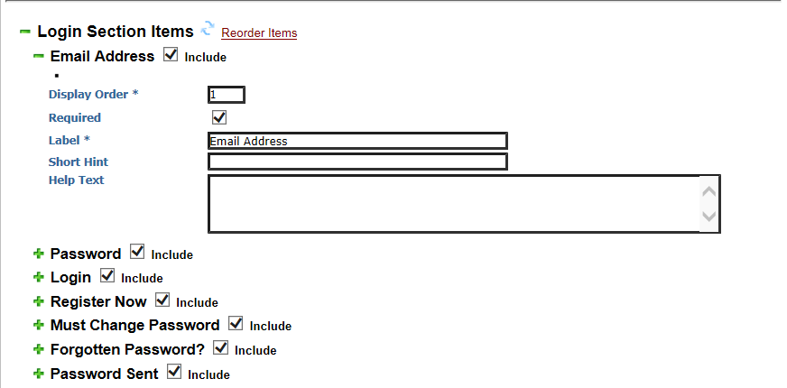

A tick in the ‘Include’ checkbox means that the section or item within a section is active and will appear in the Online Application Form Profile.

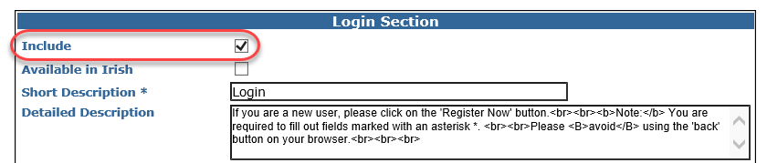

The Short Description is displayed in the section heading, and the Detailed Description appears beneath the heading – see the example below.

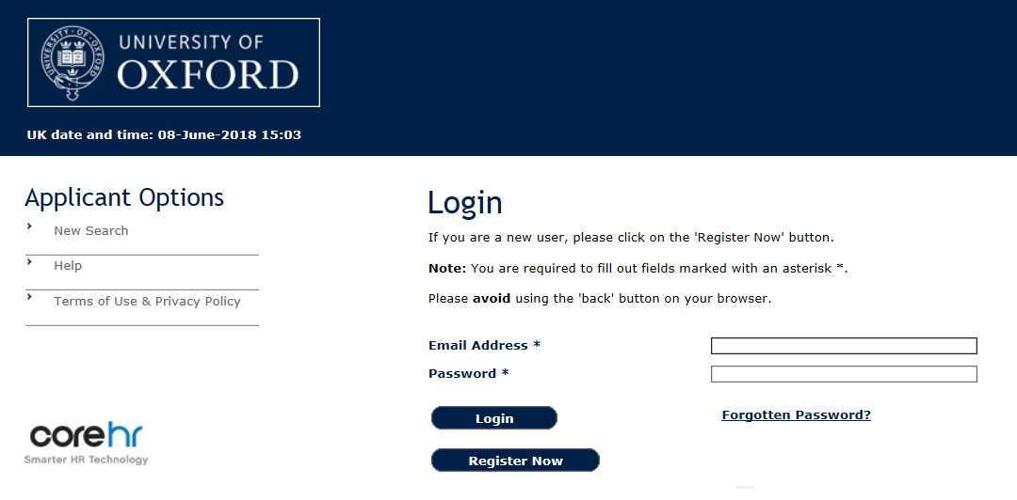

Short Hint – if used, this will show text alongside or under the field label and is visible to the applicant. Space is limited so take care not to overlay any of the existing text or drop down boxes.

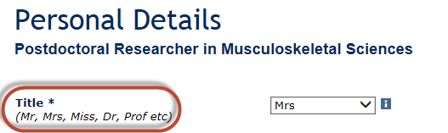

Help Text - this is additional information accessed via the to help applicants complete a field.

Standard Additional Questions section

The standard Additional Questions section is partially controlled via the Staff Portal and partially in the Back Office.

The current questions and change history can be found in the Questionnaire Setup document under P:\PROJECTS\HRIS Programme\12. Support\Reference Data\Application Form Profile Maintenance\Application Form Profile - Questionnaire Section.

Within the portal, the configuration settings determine whether this section is active and included, and whether the section as a whole is mandatory for completion. The remainder of the settings, i.e. the question wording, question section headers, question type (free text, date, yes/no, numeric etc) and whether the question is mandatory/not mandatory are maintained via the CoreHR Back Office.

It is also possible to exclude this section from an application form and if required replace it with a new set of questions via a UDF created in the back office; see the section on non-standard additional questions.

All changes should be made in a test environment in the first instance.

 | NB: It is not possible to amend or delete questions within a Question Category if it is linked to a vacancy. You will need to recreate a Question Category in order to amend or reorder the sequence questions.

Reviewing current settings

CDD spreadsheet

Note that some sections of the Online Application Form Profile exist at a higher level than others – these sections are shown in the ‘Header Sections’ tab of the spreadsheet. Changes to these sections apply to all form profiles and therefore only need to be made once (per environment) rather than to each profile individually.

The ‘Template Detail’ tab of the spreadsheet lists all sections that are controlled individually per Online Application Form Profile. Any changes to these sections must be made for online application form as applicable (i.e. to all form profiles where the relevant section is active as described in the Overview).

Questionnaire spreadsheet

The shading used on the spreadsheet:

Colour | Description
Dark Red | Used for Question Headers (we use question headers to group together related questions)
Light Red | Mandatory Questions
Light Green | Optional Questions
Yellow Highlight | Area changed in this version  Reset to standard colours for next version.
Light Orange | Not in Use

The columns explained:
Column | Explanation
Seq No | Determines in which order the questions are displayed.
Question | This is the actual wording applicants see when they complete the questionnaire section.    Note that a question header also counts as a question; it is simply a specific question type (i.e. section header).
Category Code | Each ‘group’ of questions is denoted as a ‘category’ of question in the back office reference data table. Each category has a code and a description.
Category Desc | See Category Code, above.
Answer Type | Answer options for each question can be any one of the following:  - Yes/No  - Radio Button (5 options max!)  - Drop Down  - Free Text  - Section Header  For Drop Down and Radio Button answer types, a note should be included for each on the relevant cell, to list what the current options are.
Global/Specific | All our questions are set to Global.  (There is a concept within Core to have vacancy-specific questions, originally based on the idea that users could add their own, but this was changed to ensure questions are properly reviewed and authorised before they are used).
Select Ind |   If a question or question header select indicator is ticked, that question (or category) is automatically included (‘presented') when a new vacancy is being created.
Active Ind | If a question or question header select indicator is set to active, it is available for a user to add it to the questionnaire section for a vacancy.  Questions/question headers that are not active will also show in the vacancy profile – they will not show in the questionnaire preview and live questionnaire view seen by applicants. Recruitment administrators cannot include a question if it is not set to active in the back office.
Mandatory | Indicated by *. Applicants cannot save the questionnaire section or submit their application without answering the mandatory question(s).
Private | The answers to Private Questions are visible to recruitment administrators when they view applications.  However, they (and the related questions) are excluded from the PDF application packs generated by the system.
Notes/Comments for this version! | Used to make any notes relating to a change made for the latest version of the Questionnaire spreadsheet.

Maintaining Documentation
Once it is agreed that a change will be taken forward, a new version of the CDD spreadsheet should be saved and updated to reflect the changes being made.

Change History tab:
Record here who made the change and when, as well as the related HEAT change reference and the ‘from’ and ‘to’ change details.

Related documents

Current configuration settings and changes to the profile are tracked in two Common Design Documents (CDD) saved in the following folder:

P:\PROJECTS\HRIS Programme\12. Support\Reference Data\Application Form Profile Maintenance

There is one CDD for the Layout and Content and one for the Questionnaire Section. It is important to refer to these documents before any change are made and also to make sure that they are updated after changes have been made.

HOW TO_Maintain the Applicant Login page
HOW TO_Maintain Online Application Forms

